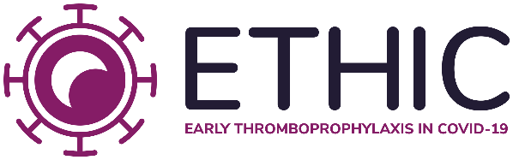

Patient Information Leaflet

Why have I been invited to take part?
- You are being invited to take part in the ETHIC study as you have a positive COVID-19 diagnosis and are considered to have an increased risk of needing admission to hospital over the next three weeks.
- Before you decide whether to take part, it is important for you to understand why the research is being done and what it will involve. Please take time to read the following information carefully.
- You are free to decide whether or not to take part in this study. If you choose not to take part, this will not affect the care you get from your own doctors.
- If you do take part, you would be free to withdraw at any time without giving any reason.

Background
- In March 2020, the World Health Organisation categorised coronavirus (COVID-19) a pandemic. By June 2020, over 6 million cases had been confirmed in over 180 countries, with over 350,000 deaths.
- Recent evidence has shown that COVID-19 infections can cause blood clots. This can lead to worsening of the condition in some people, leading to hospital admission, or unfortunately in severe cases, death.
- Enoxaparin is a blood-thinning drug which has been used by doctors and nurses in hospitals for many years to help prevent blood from getting too thick and forming a clot.
- It is easier for doctors to prevent new blood clots from forming than treating existing blood clots.
- Currently, there are no treatments for COVID-19 in the early stages. There is an urgent need to find a safe and effective treatment to prevent worsening of the disease.

Description of study
- The study will take place in approximately 8 to 10 countries, in approximately 30 to 50 centres.
- Half the people in the trial will receive standard care for those with COVID-19. The other half will in addition receive the blood-thinning drug enoxaparin for 21 days. You will be randomly allocated to one of these groups.
- After 21 days, we will compare the outcomes of each group, including how many people developed a blood clot, or were admitted to hospital.
- Further comparisons will be made 50 days and 90 days after the beginning of the study.
- By participating, you will be helping with research to improve the treatment of COVID-19 for future patients.

What is the purpose of the study?
- We want to find out if giving a blood-thinning drug (enoxaparin) at an early stage of the COVID-19 infection can prevent harmful outcomes, such as the need for hospital admission.

What will happen if I take part?
- If you agree to take part, you will be asked to sign a consent form for this research study.
- You will then be randomly allocated a treatment and basic information will be taken (e.g. gender, date of birth, body mass index) as well as details on your COVID-19 diagnosis, symptoms, and any medical conditions you may have.
- If you are allocated enoxaparin, you will be required to take this medication once (or twice if you weigh >100 kg) a day for 21 days.

Will the information I provide be kept confidential?
- Yes, all information collected for the study at any time will be kept secure and confidential.

How will the information I provide be used?
- The results of the study will be published in a scientific journal. Patients will not be identifiable in any of the study reports.

Who is doing this study?
- This study is being conducted by the Thrombosis Research Institute, London, United Kingdom.

